SMDM PROJECT REPORT

(Business Report)

Contents:

- Problem1: Wholesale Customers Analysis Page No.

- Summary of the problem statement………………………………………………………….........................3
- Introduction……………………………………………………………………………………………………………………………………3
- Data description…………………………………………………………………………………………………………………………..3
  - Sample of the dataset…………………………………………………………...…….................................3
  - Top 10 records of the dataset……………………………………………………………………………………..4
- Exploratory data analysis…………………………………………………………………………………………………………4
- Describing the dataset……………………………………………………………………………………………………………….4
- Information of the data………………………………………………………………………………………………………………5
- Checking the null values……………………………………………………………………………………………………………5
- Q1.1 Use methods of descriptive statistics to summarize data. Which Region and which Channel spent the most? Which Region and which Channel spent the least………………………..6
  - Showing the region………………………………………………………………………………………………………….6
  - Showing the channels…………………………………………………………………………………………………….6

Q1.2 There are 6 different varieties of items that are considered. Describe and comment/explain all the varieties across Region and Channel? Provide a detailed justification for your answer…………………………………………………………………………………………………………………………….6
- Showing the varieties across regions and channels……………………………………………………..6
- Checking the outliers in the data…………………………………………………………………………………………….9

Problem 2: Students survey

- Summary of the problem statement…………………………………………………………............................10
- Introduction………………………………………………………………………………………………………………………………………10
- Data description……………………………………………………………………………………………………………………………..10
  - Sample of the dataset…………………………………………………………...……....................................11
- Top 10 records of the dataset…………………………………………………………………………………………………….11
- Contingency tables…………………………………………………………………………………………………………………………11
- Describing the dataset………………………………………………………………………………………………………………….12
- Information of the data………………………………………………………………………………………………………………….
- Assume that the sample is representative of the population of CMSU. Based on the data, answer the following question.………………………………………………………………………………………………………………….

2.2.1. What is the probability that a randomly selected CMSU student will be male?......13
- 2.2.2. What is the probability that a randomly selected CMSU student will be female?.........13

2.3. Assume that the sample is representative of the population of CMSU. Based on the data, answer the following question………………………………………………………………………………………………………..13

2.3.1. Find the conditional probability of different majors among the male students in CMSU……………………………………………………………………………………………………………………………………………………………………..13

2.3.2 Find the conditional probability of different majors among the female students of CMSU………………………………………………………………………………………………………………………………………………………………………13

2.4. Assume that the sample is a representative of the population of CMSU. Based on the data, answer the following question:

2.4.1. Find the probability that a randomly chosen student is a male and intends to graduate……………………………………………………………………………………………………………………………………………………………….14

2.4.2 Find the probability that a randomly selected student is a female and does NOT have a laptop………………………………………………………………………………………………………………………………………………………………….14

2.5. Assume that the sample is representative of the population of CMSU. Based on the data, answer the following question:

2.5.1. Find the probability that a randomly chosen student is either a male or has full-time employment?...........................................................................................................................................14

2.5.2. Find the conditional probability that given a female student is randomly chosen, she is majoring in international business or management……………………………………………………………………14

__________..............._________

Summary of the problem statement
A wholesale distributor operating in different regions of Portugal has information on annual spending of several items in their stores across different regions and channels. The data consists of 440 large retailers’ annual spending on 6 different varieties of products in 3 different regions (Lisbon, Oporto, Other) and across different sales channel (Hotel, Retail).

Introduction
The purpose of this whole exercise is to explore the dataset. Do the exploratory data analysis. Explore the dataset using central tendency and other parameters. The data consists of 440 large retailers’ annual spending on 6 different varieties of products in 3 different regions (Lisbon, Oporto, Other) and across different sales channel (Hotel, Retail). This assignment should help the student in exploring the summary statistics, contingency tables, conditional probabilities & hypothesis testing.

Data description
- Buyer/Spender: The count of buyer or spender.
- Channel: The type pf channel (retail or hotel)
- Region: The area or sector in which channel are located.
- Fresh: One of the six varieties between which trade happen.
- Milk: One of the six varieties between which trades happen.
- Grocery: One of the six varieties between which trade happen.
- Frozen: One of the six varieties between which trade happen.
- Detergents Paper: One of the six varieties between which trade happen.
- Delicatessen: One of the six varieties between which trade happen.

Sample of the dataset
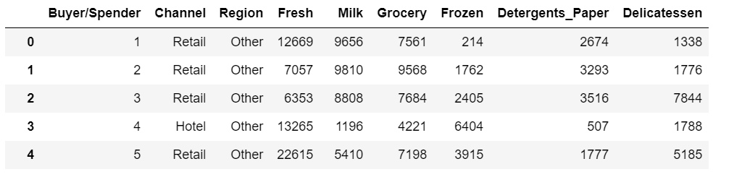
…

Top 10 records of the dataset
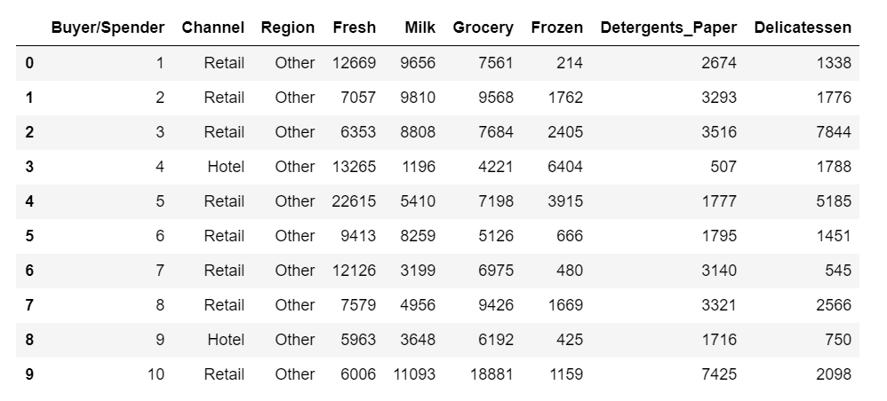

Exploratory data analysis:
Describing the dataset

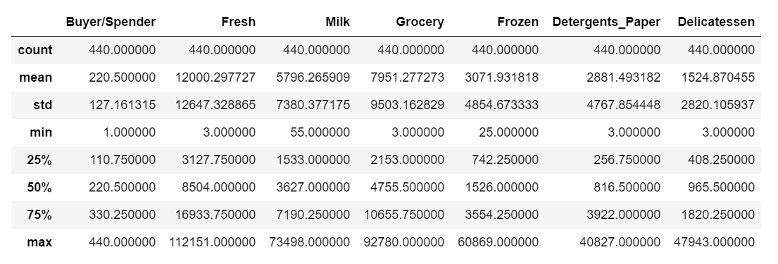

Information of the data:

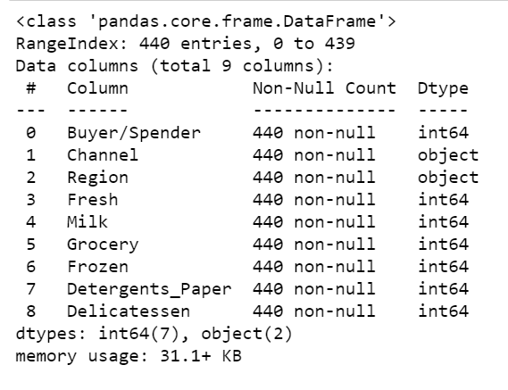

Checking the missing values:

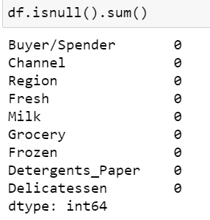
Q1.1 Use methods of descriptive statistics to summarize data. Which Region and which Channel spent the most? Which Region and which Channel spent the least.

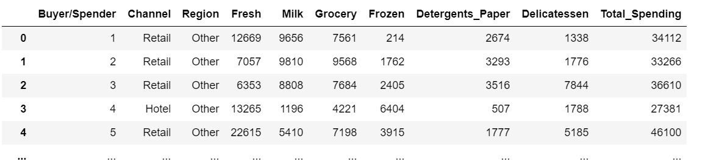

Showing the region and spending:
Region
Lisbon 2386813
Oporto 1555088
Other 10677599
Name: Total_Spending, dtype: int64

Showing the Channel and spending:

Channel
Hotel 7999569
Retail 6619931
Name: Total_Spending, dtype: int64

Q1.2 There are 6 different varieties of items that are considered. Describe and comment/explain all the varieties across Region and Channel? Provide a detailed justification for your answer.
Showing the varieties across regions and channels:
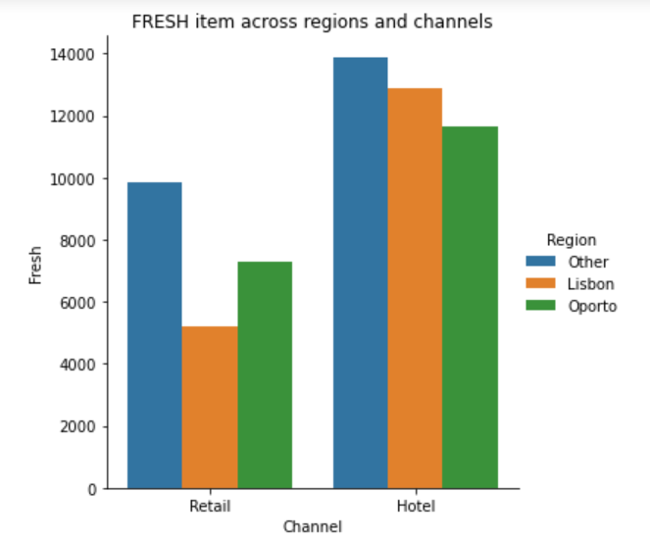
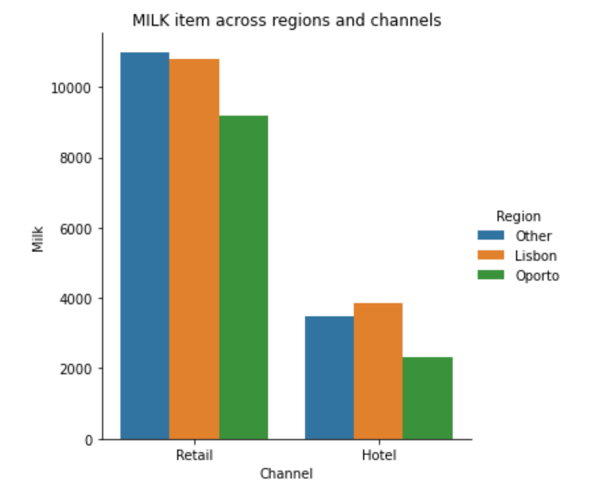
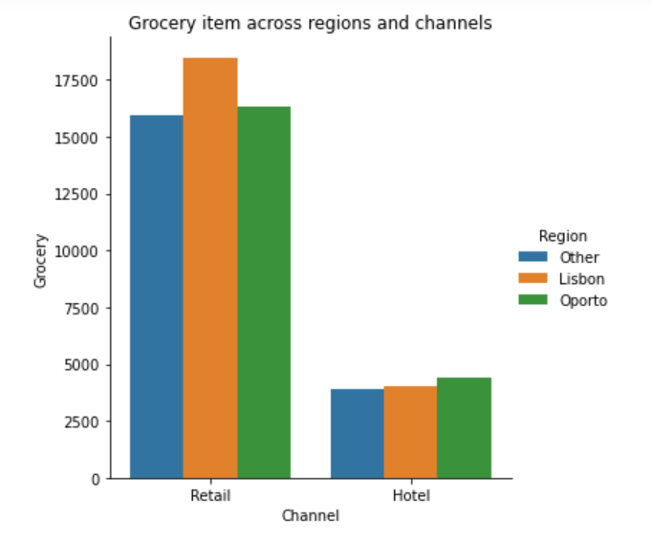
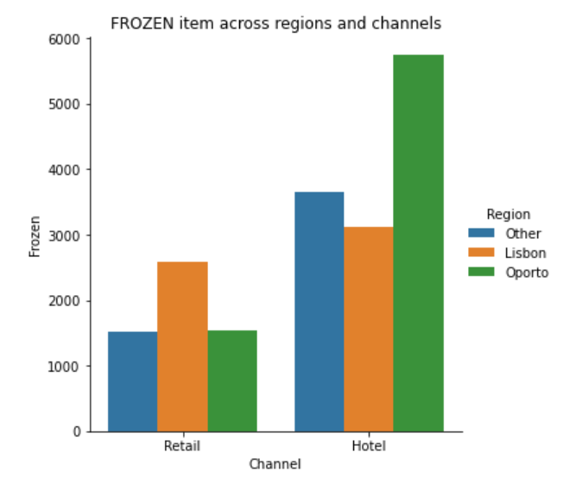

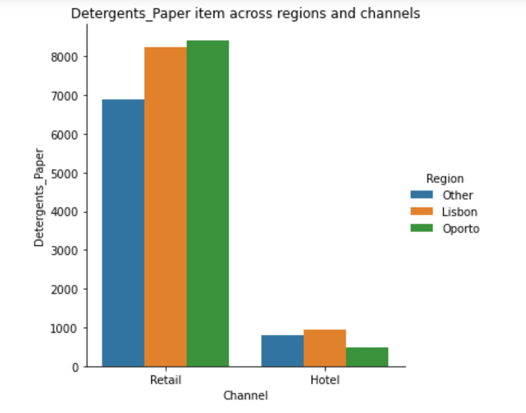
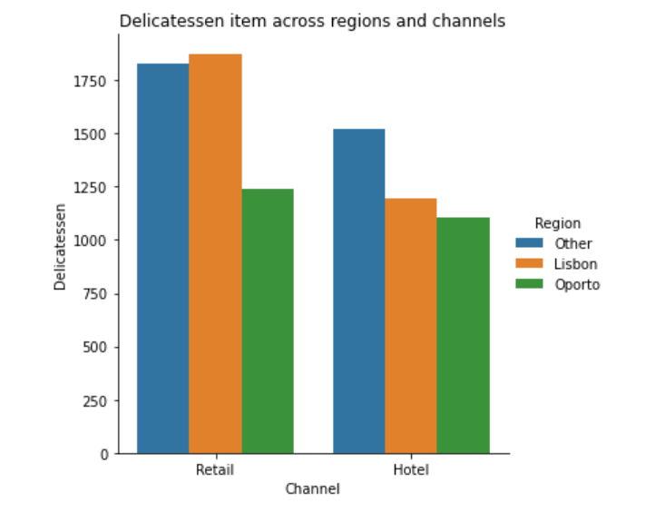

Checking the outliers in the data:
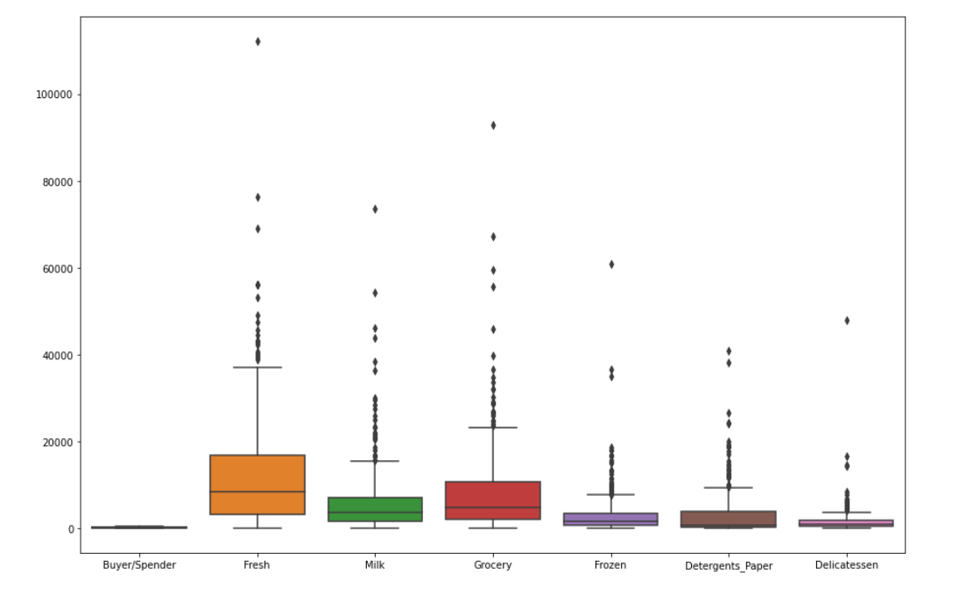

Problem 2: Students survey:

Summary of the problem statement
The Student News Service at Clear Mountain State University (CMSU) has decided to gather data about the undergraduate students that attend CMSU. CMSU creates and distributes a survey of 14 questions and receives responses from 62 undergraduates (stored in the Survey data set).

Introduction
The purpose of this whole exercise is to explore the dataset. Do the exploratory data analysis. Explore the dataset using central tendency and other parameters. The Student News Service at Clear Mountain State University (CMSU) has decided to gather data about the undergraduate students that attend CMSU. CMSU creates and distributes a survey of 14 questions and receives responses from 62 undergraduates (stored in the Survey data set). This assignment should help the student in exploring the summary statistics, contingency tables, conditional probabilities & hypothesis testing.

Data description:

ID: Student id.
Gender: Gender of the students in the survey.
Age: Age of the students
Class: Divided students based on class/section
Major: Field in which they work
Grad Intention: Students intended with graduation
GPA: Grade point average of the students in their respective fields/major
Employment: Whether students are employed and their type (part time, full time)
Salary: Salary of the students
Social Networking: How many social sites they use
Satisfaction: Their satisfaction level scale
Spending: Their expenditure
Computer: kind of computer they have (laptop, desktop, tablet)

Sample of the dataset

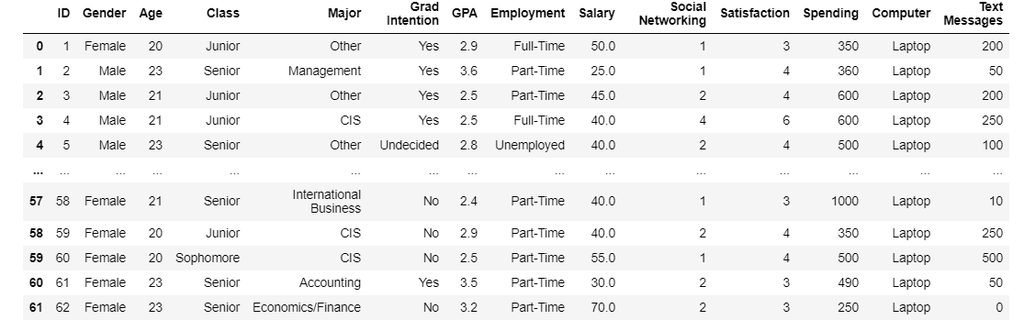

Top 10 records of the dataset
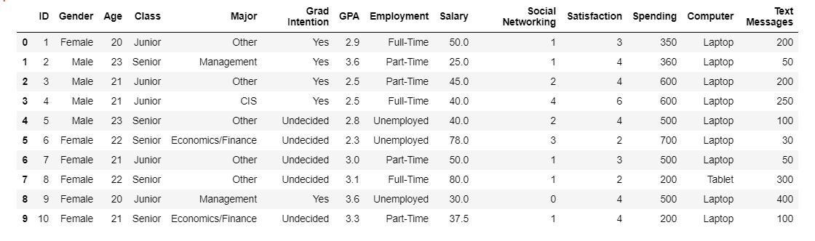

Contingency tables
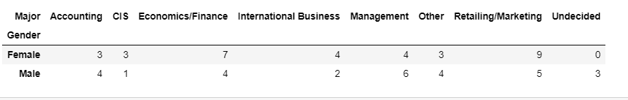

Describing the dataset
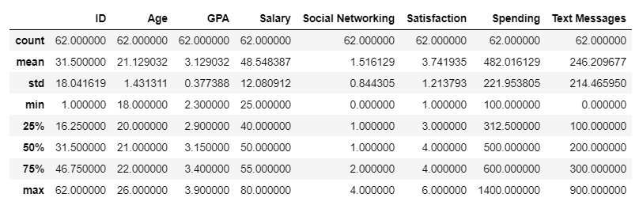

Information of the dataset
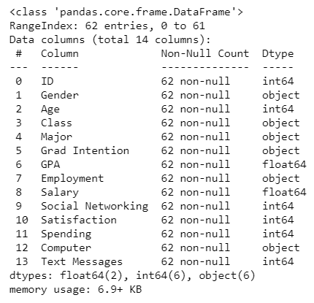

2.2.1. What is the probability that a randomly selected CMSU student will be male?
- Probability that a randomly selected CMSU student will be male is: 0.46774193548387094

- 2.2.2. What is the probability that a randomly selected CMSU student will be female?
- Probability that a randomly selected CMSU student will be female is: 0.532258064516129

2.3. Assume that the sample is representative of the population of CMSU. Based on the data, answer the following question……………………………………………………………………………………………………………

2.3.1. Find the conditional probability of different majors among the male students in CMSU.
- Probability of male students in Accounting is: 0.13793103448275862
- Probability of male students in CIS is: 0.034482758620689655
- Probability of male students in Economics/Finance is: 0.13793103448275862
- Probability of male students in International_Business is: 0.06896551724137931
- Probability of male students in Management is: 0.20689655172413793
- Probability of male students in Other is: 0.13793103448275862
- Probability of male students in Retailing/Marketing is: 0.1724137931034483
- Probability of male students in undecided is: 0.10344827586206896

2.3.2 Find the conditional probability of different majors among the female students of CMSU.
- Probability of female students in Accounting is: 0.09090909090909091
- Probability of female students in CIS is: 0.09090909090909091
- Probability of female students in Economics/Finance is: 0.21212121212121213
- Probability of female students in International_Business is: 0.12121212121212122
- Probability of female students in Management is: 0.12121212121212122
- Probability of female students in Other is: 0.09090909090909091
- Probability of female students in Retailing/Marketing is: 0.2727272727272727
- Probability of female students in undecided is: 0.0

2.4. Assume that the sample is a representative of the population of CMSU. Based on the data, answer the following question:

2.4.1. Find the probability that a randomly chosen student is a male and intends to graduate.
- Probability that a randomly chosen student is a male and intends to graduate is: 0.27419354838709675

2.4.2 Find the probability that a randomly selected student is a female and does NOT have a laptop.
- Probability that a randomly selected student is a female and does NOT have a laptop is: 0.06451612903225806

2.5. Assume that the sample is representative of the population of CMSU. Based on the data, answer the following question:

2.5.1. Find the probability that a randomly chosen student is either a male or has full-time employment?

0.3876529477196885

2.5.2. Find the conditional probability that given a female student is randomly chosen, she is majoring in international business or management.

  - Probability of female majoring in international business or management is: 0.12903225806451613

